|  |  |  |  |  |  |
| --- | --- | --- | --- | --- | --- |
| Date | 30-Nov-22 | | | Tester Name | Jessie Liu |
| Environment | Select Environment | | | Login used |  |
| Operating System | Select OS | Version: | Update: | | |
| Software Used | Select Software | Version: | Update: | | |
| Select Software | Version: | Update: | | |
| Release version |  | | | | |
| Title | Update Personal Information | | | | |
| Test Type | Regression | | | | |
| Test Scenario | Update a member address, phone number, email, name | | | | |
|  |  | | | | |
| Expected Results |  | | | | |
| Pass/Fail | Pass | | | JIRA# | N/A |

Describe your steps with screenshots:

1. Find a member

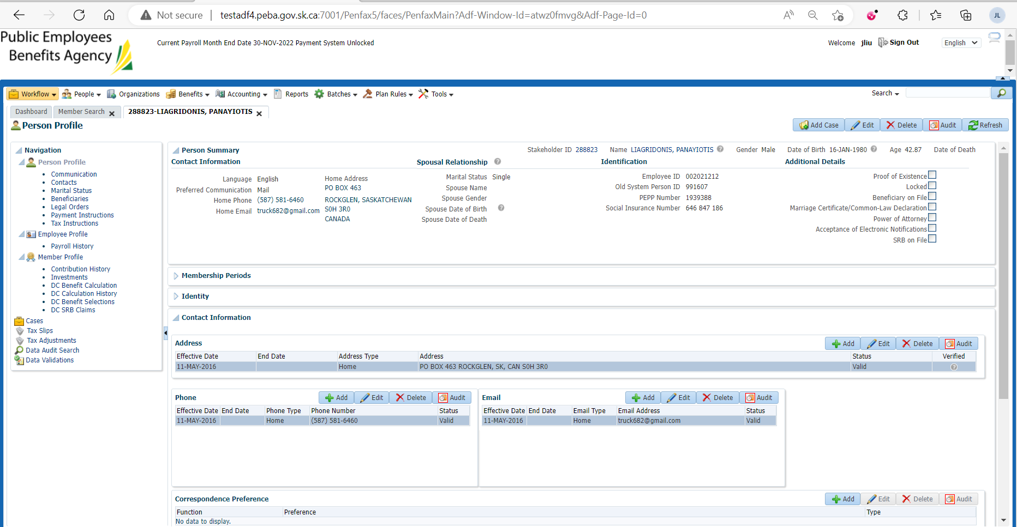

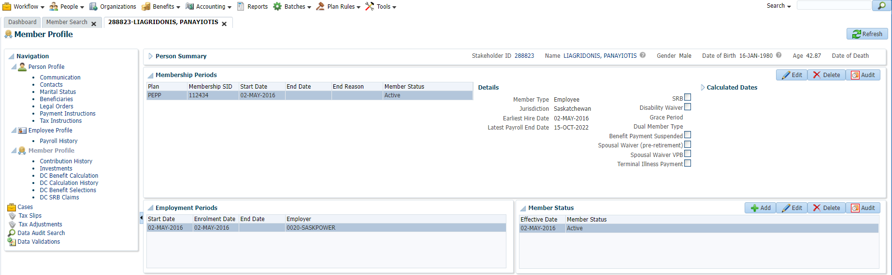

1. Update the member address

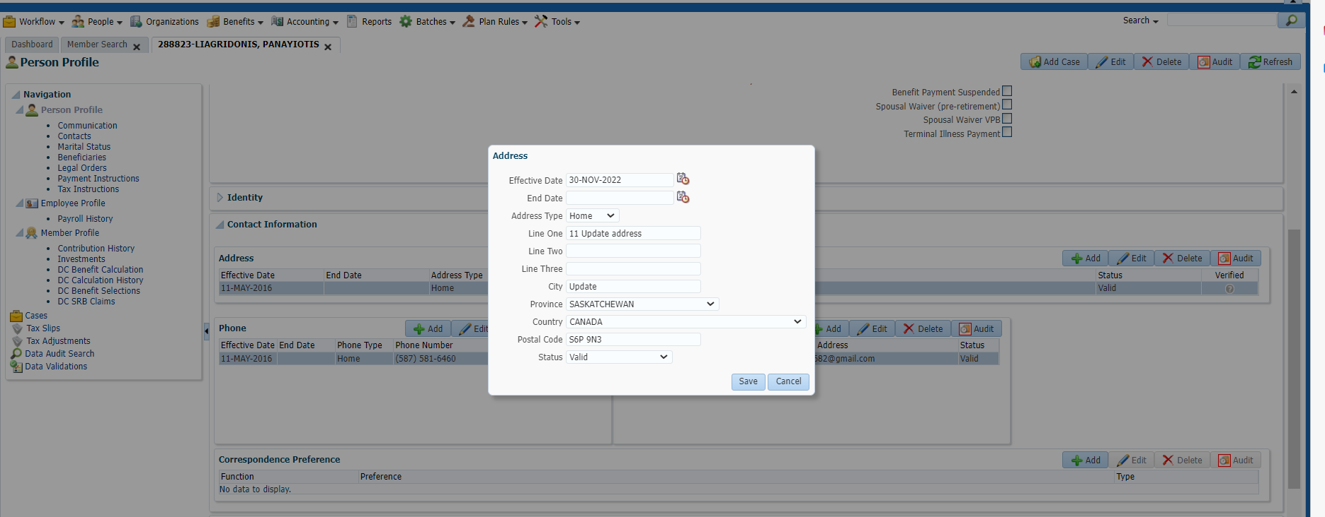

The address is updated

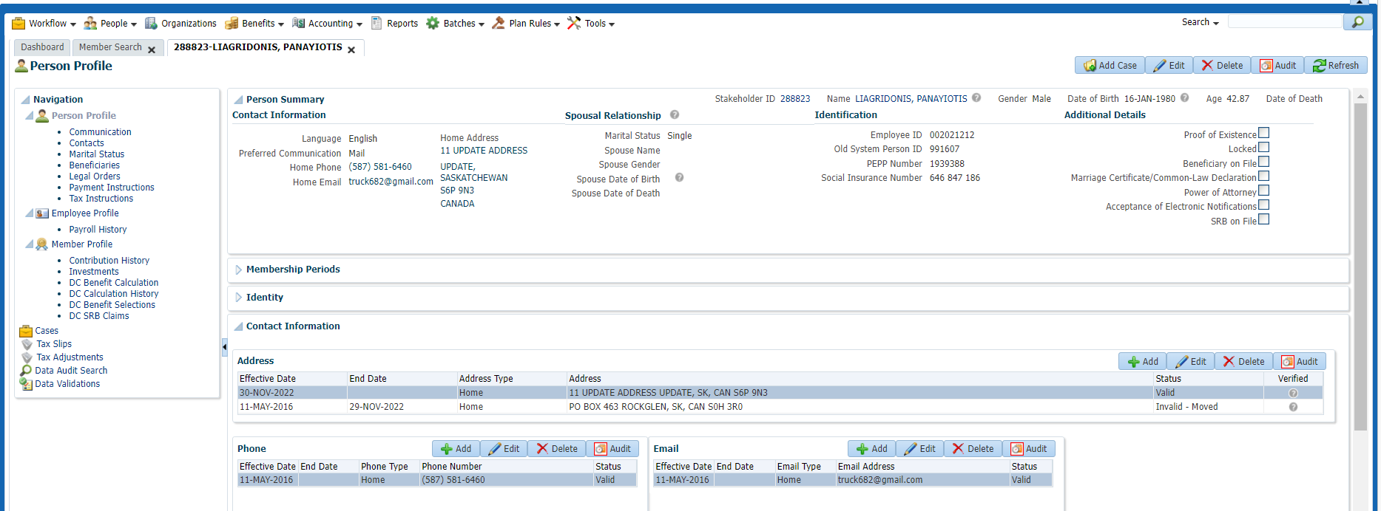

1. Update Phone

Add status – invalid for previous phone

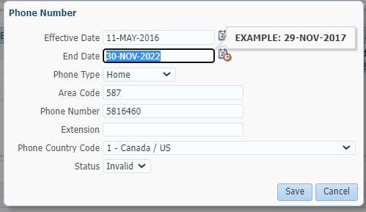

Add new phone number

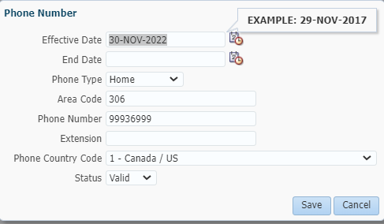

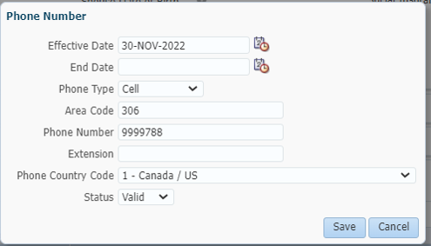

The phone is updated

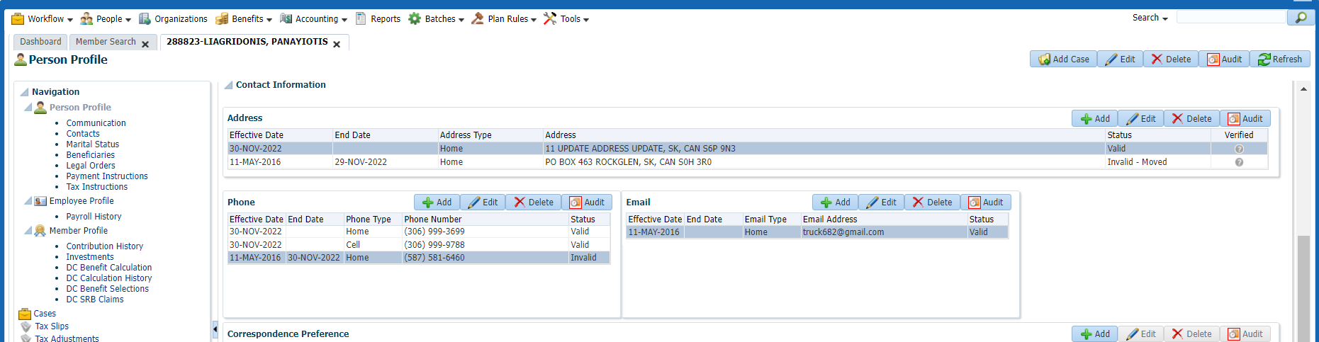

1. Update email

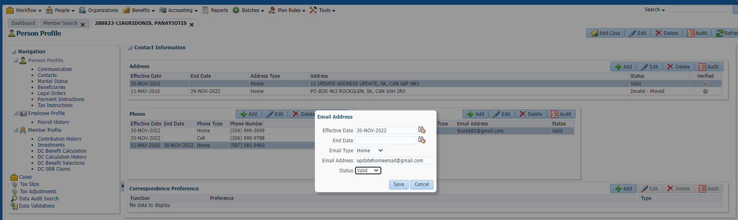

And end previous one

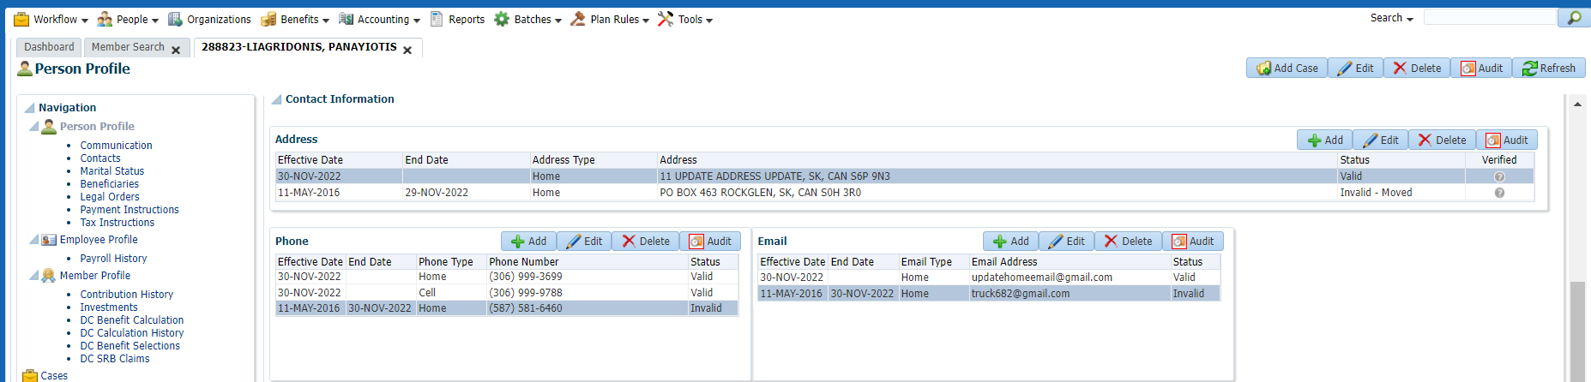

1. Update the member name

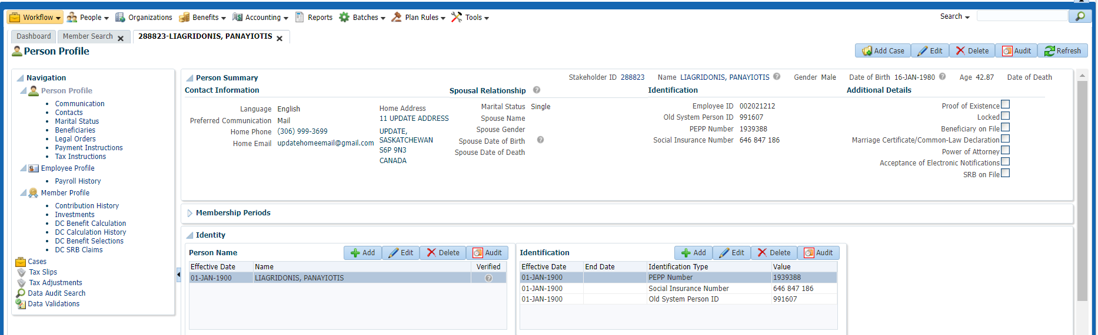

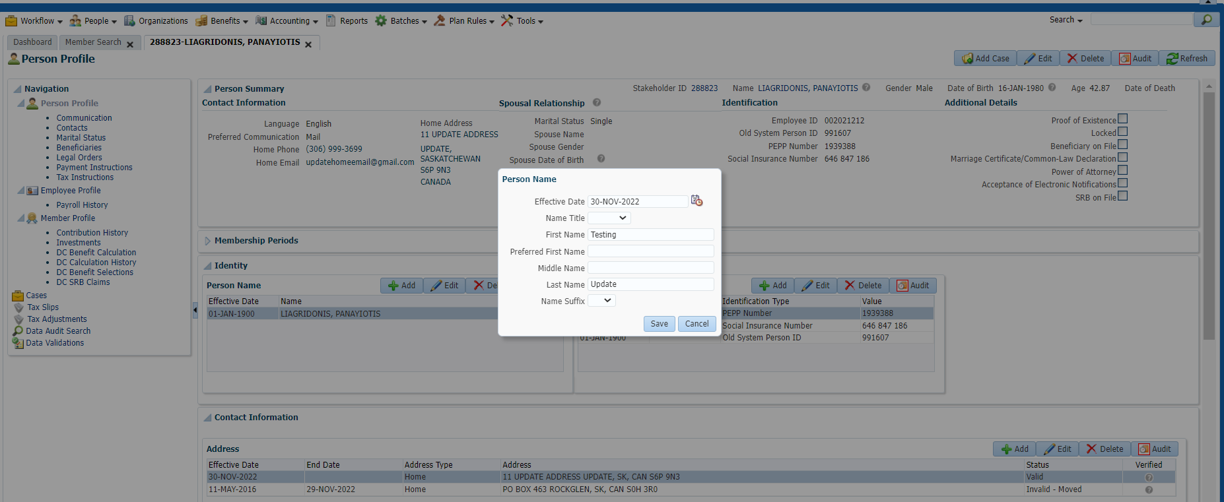

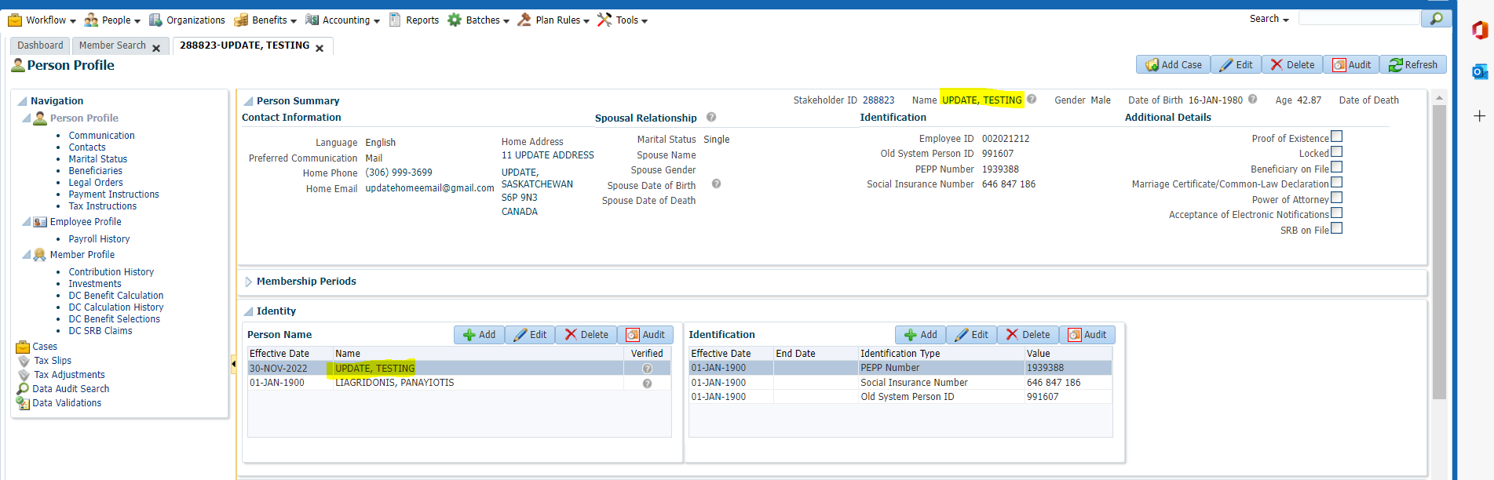

1. Letter

